Ship Happens

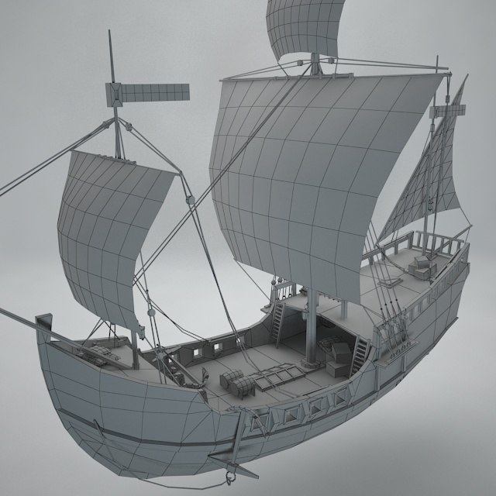

level 6 group 3

Henry Crofts & Tom gibbs

Contents

Game Logline 4

Game Loop 4

Target Demographic 4

Psychographic 4

Game Platform 5

Player Input 5

Game Scene (IMAGE) 5

User interface 5

Cannon contents (attached to each cannon 5

crow’s nest indications 5

Ship health 6

Distance from level end 6

Using level resources/items 7

Mechanics 7

Player movement: 7

Player interactions (explained in greater detail in subsequent bullet points): 7

Flooding and Bail water: 7

clean deck 8

enemy behaviour 8

player cannons 9

repair deck 11

whale 12

Steer ship 12

Retrieve material from hold 13

Crow nest telegraphing 13

Rewards: 14

Resources: 14

In level resources 14

characters 14

Who or what are characters in the game 14

Assets 14

3D assets 14

Included within asset pack: 15

3D assets included in pack which team will need to modify: 15

3D assets team will produce: 15

Animations: 16

Particle effects: 16

2D / UI assets: 16

MVP Design Overview Flowchart 16

Initial level (tutorial) gameplay 17

# Game Logline

Local coop resource management game where players must coordinate to overcome hazards and manage activities, figuring out the optimal strategy.

# Game Loop

ASSESSS

COMMUNICATE

ACT

PLAN

* Assess: players must focus and react to on screen activity/prompts
* Communicate: players must make their capacity known to reveal options
* Plan: decide which team members are most appropriate to assign to necessary tasks
* Act: players must manage activities/hazards to keep ship afloat

On completion of level team will receive performance-based rewards to customise their in-game avatars

# Target Demographic

The demographic for our game will be for males aged between 13-24 who play across a range of different platforms, primarily;

* Windows PC.
* Microsoft Xbox One.
* Sony PlayStation 4.
* Nintendo Switch.

Players should reside within any English-speaking region as all text and audio assets will be produced in English.

Players will not need to have any form of official education, only the ability to read and understand English.

# Psychographic

For our psychographic we have created Terry Goldhorn. A 20-year-old studying Sport Sciences as a full-time student. Terry has an afternoon job lasting 4 hours, starting at 2:00PM and finishing at 6:00PM. Terry enjoys going out for runs in the morning when he wakes up before attending his lectures at 9:00AM. Terry is always hanging around with his friends, either going out to do various activities or playing video games in the evening. For a full description of Terry Goldhorn please refer to our psychographics file located [here](https://github.com/UoSGroupProjects1819/game-project-group-3/tree/master/Development%20plans).

# Game Platform

## Player Input

The game will be developed initially for Windows PC where players will use Xbox One controllers to navigate around the ship deck. Players will also need to be able to interact with objects around the ship such as, but not limited to, the cannons, bucket and cargo hold.

Development for consoles is not within the scope of the Minimum Viable Product (MVP) but future development would see the game release to Microsoft Xbox One, Sony PlayStation 4 and Nintendo Switch as such the control scheme would be adapted to work with each corresponding console’s respective controller.

## Game Scene (IMAGE)

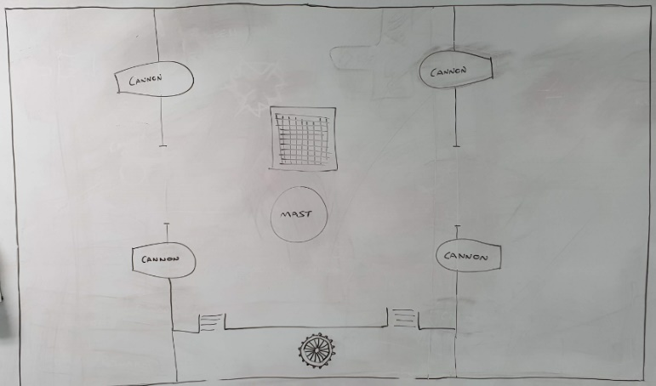

# User interface

Game scene UI will feature:

## Cannon contents (attached to each cannon

* Indicates resources the cannon requires to be loaded and what is currently loaded into the cannon.

## crow’s nest indications

* Crow’s nest speaks in pictures
  + Will be used within tutorial prompts to describe events to players.
  + Used to signal hazards to players (hazard and direction of hazard if applicable).

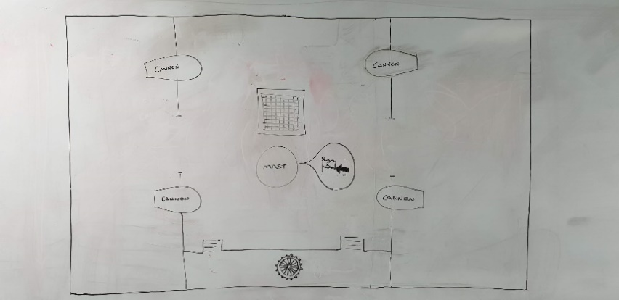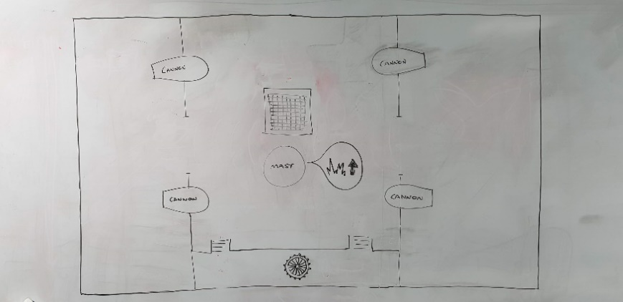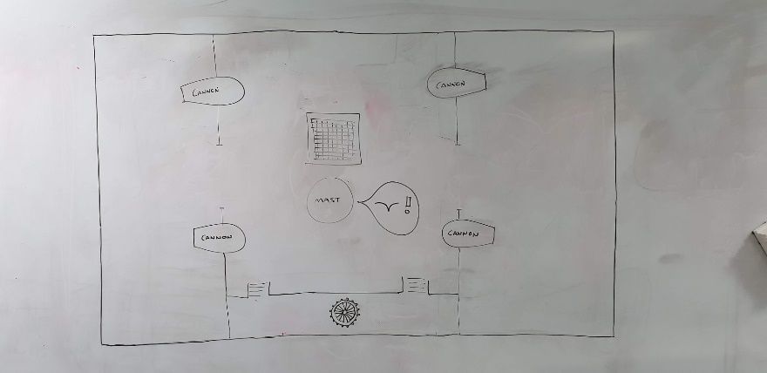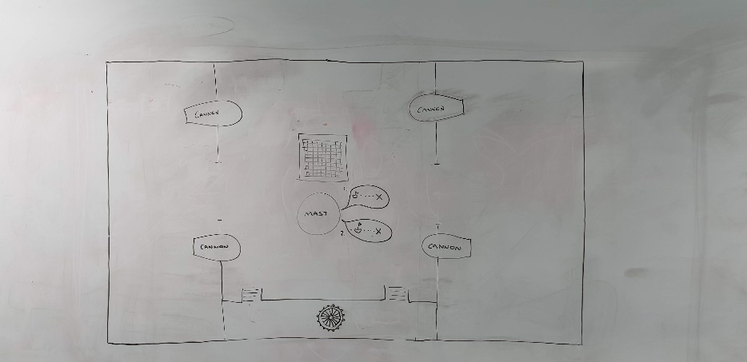

## Ship health

* 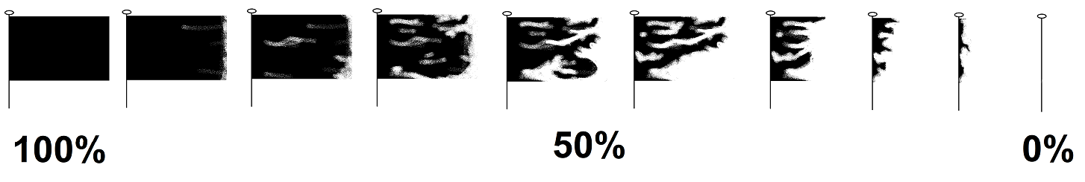Represented by ships flag which becomes more tattered the closer the ship gets to the lose condition.
* The water shown on the deck of the players ship will also visually show how close they are to the lose condition, trying to incite panic as the water level fills up making it harder for the players to move around the scene.

## Distance from level end

* Numerical values will not be used to represent remaining distance (time) to level end.
* Visual representations of distance will let players quickly scan the screen

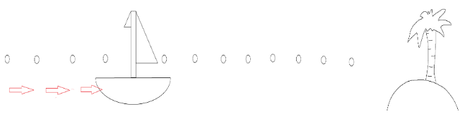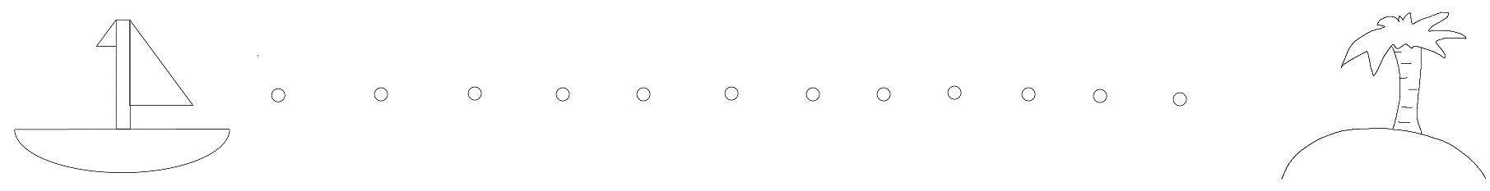

## Using level resources/items

* + Described more thoroughly in ‘mechanics’ section. When player proximity is within set range, the ship hold will show a directional pad which shows which direction corresponds to which resource.
  + 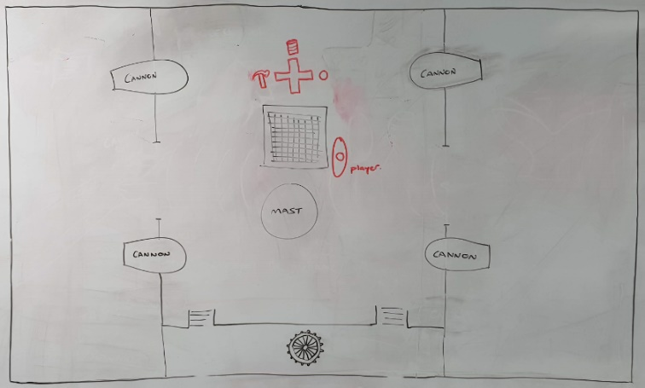This UI element will also show whether a resource is available, or recharging.

# Mechanics

## Player movement:

* Player must be allowed to move about ship deck. Players will ‘walk’ (slide) along deck surface in direction of controller input. Players do not have ability to jump.

## Player interactions (explained in greater detail in subsequent bullet points):

* All player interactions are carried out with the intention of repairing damage done to the ship, reducing damage done to the ship, or avoiding damage done to the ship
* Player must be able to interact with map activities via use of action button(s)
* Player must be able to use the controller directional pad to retrieve corresponding items from the ship lower deck
* Player must be able to pick up/use/drop scene tools.

## Flooding and Bail water:

* As the ship becomes damaged, water will slowly flood the deck while damage is unrepaired.
* The higher the water level, the more friction will be applied to players, slowing their movement speed.
* Players can retrieve buckets to bail water from the deck, reducing the rate at which the will flood if there is active damage or reducing the water level if the deck is fully repaired.
* Bucket can be picked up, used if water on deck, and dropped by the player.

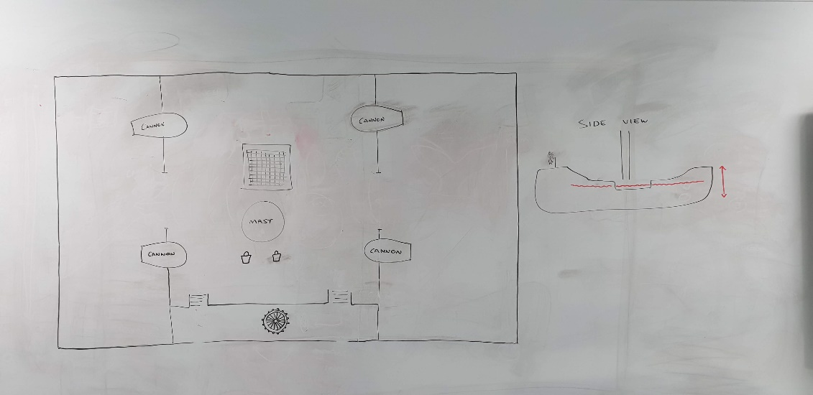

## clean deck

* Periodically a seagull will fly over the ship deck (only shadow is visible to the players to indicate incoming hazard)
* Bird poo will be dropped onto the deck, if stepped in players friction will be reduced to give controls an ‘ice-skates’ feel.
* Players can retrieve mop from the deck, to clean away the mess.
* Mop can be picked up, used if near mess, and dropped by the player.

## enemy behaviour

* Enemy presence and screen side position will be indicated via Crow’s nest UI
* Enemy will start at either screen top or bottom (randomly)
* If starting from bottom enemy will move upward, if starting top enemy will move downward
* Flag representing enemy type will indicate relative position of enemy ship
* 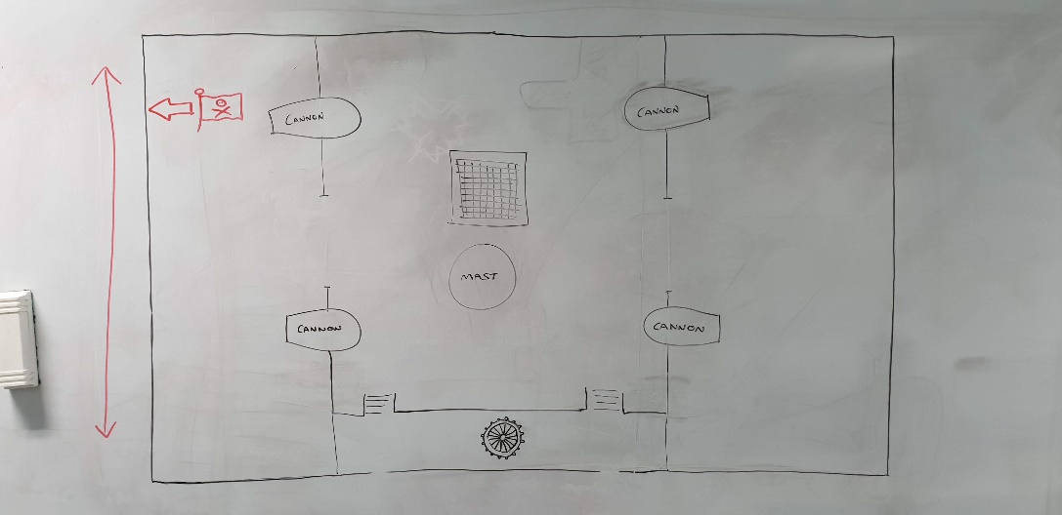Only one cannon can hit an individual enemy ship at any time, the cannon in ‘range’ will throb and pulse with colour when the player is able to fire it to land a successful hit on the enemy
* 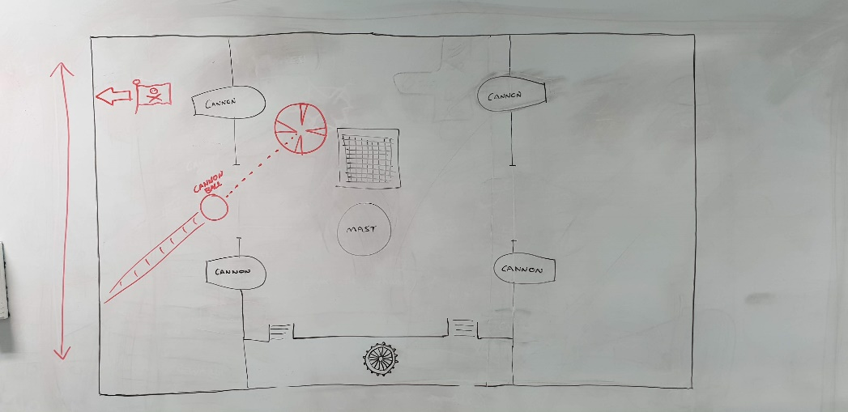If the enemy ship reaches the opposite end of the screen without being damaged, they will fire a cannon ball onto the player deck
* Players will be given indication of where cannon ball will land with overlaid reticule marker
* If a player or item is struck by the incoming cannon ball they are knocked from the deck and must respawn

## player cannons

* Cannons will display there ‘loaded contents’ with small UI elements above them
* UI indicates the ammunition required by the cannons before they can be fired
* 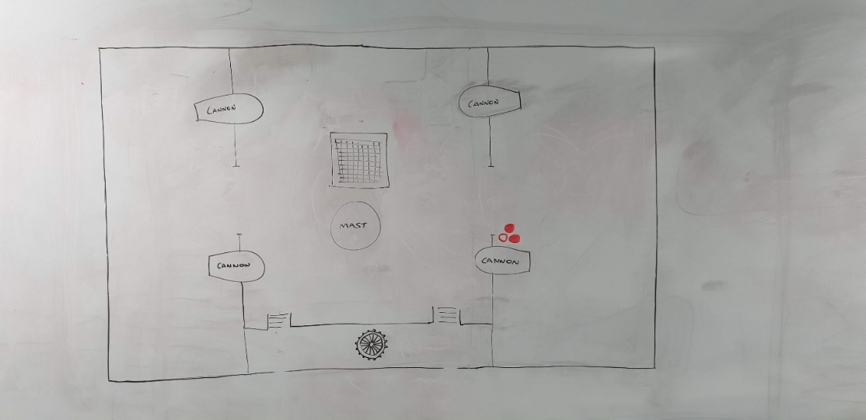As cannons are loaded, these UI icons will be replaced by the cannons loaded contents
* A loaded cannon can be fired at any time
* One only cannon will be able to strike an individual enemy at any one time
* A cannon able to strike an enemy will pulsate/throb and colour shift
* 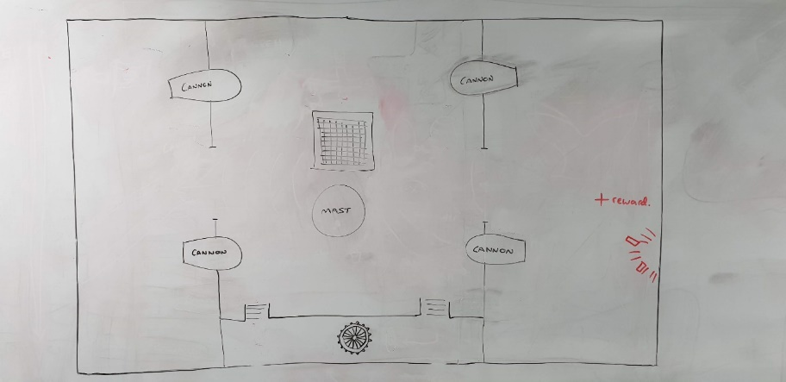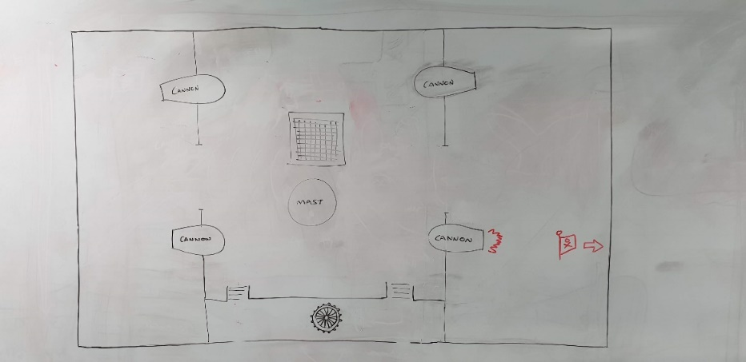Successful cannon hits on enemies will trigger a particle effect to indicate successful action to the player

## repair deck

Damage caused by enemy cannon fire is repairable by the player through use of the “wood” resource, obtainable from the ship hold (item operates on a recharge timer)

* Player must obtain wood from hold
* 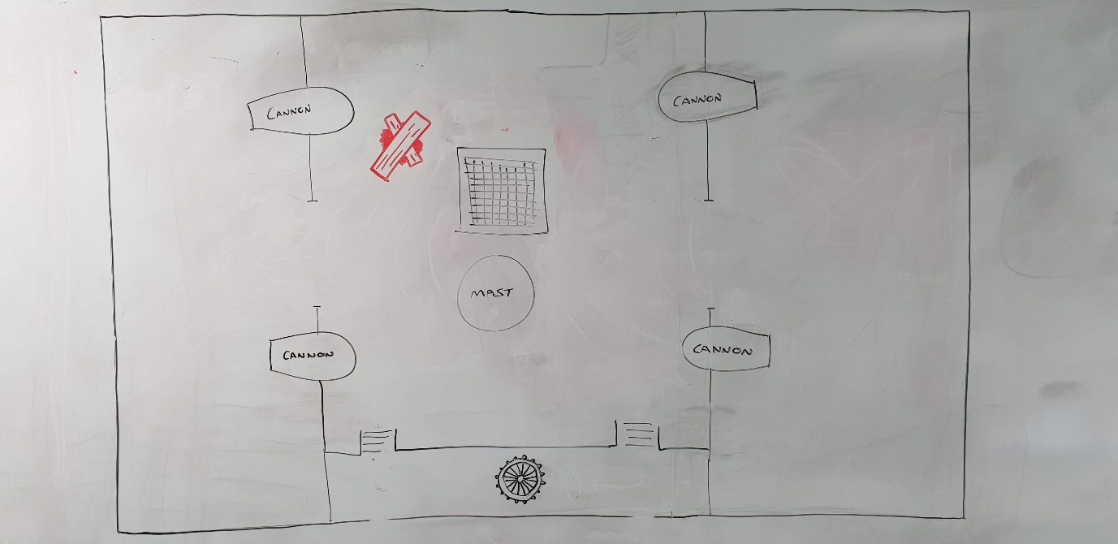Carry wood to damaged area
* Player can then press action button to begin repair, which will happen over a set time
* Rate of water fill from this damage will reduce until repair is complete, where this damage will cease contributing to the deck flooding
* Player-repaired areas are weaker than the decks normal state

## whale

* 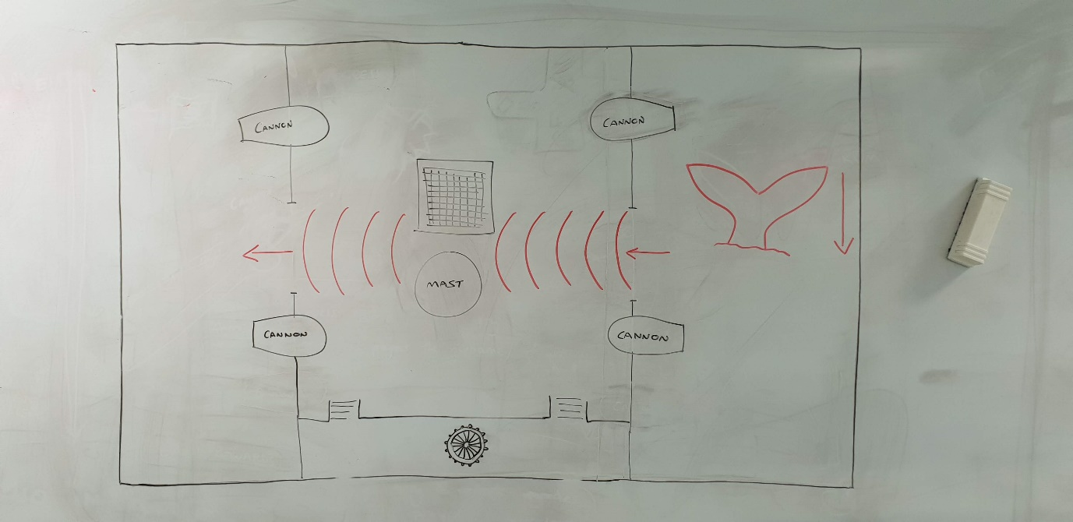To indicate the incoming hazard to players, the whale’s tail will rise from surrounding water, fall back below water level
* Waves will start from side of ship the whale tail appeared, move towards the ship and across the deck.
* Waves will wash across the horizontal mid-section of the deck and was any players and dropped items in this zone will be pushed from the ship. Any players or items washed off will be brought back into play after a respawn timer.

## Steer ship

* The crow’s nest will indicate an obstacle hazard to the player.
* Players must then move themselves to the ship’s wheel and rotate the thumb stick (either left or right) to move the ship out of the collision path
* Action will cease after short duration, player will be informed from the crow’s nest that the obstacle is no longer obstructing the ships path

## Retrieve material from hold

* Player must walk to opening of hold (players are unable to walk over the top of the hold)
* When close enough to ship’s hold, UI element will be displayed over the hold opening, indicating which resource corresponds to each direction
* If obtained, the corresponding icon will be greyed – indicating it is now unavailable
* The colour of the icon will slowly return, returning in a clockwise rotation
* When colour has returned, resource is available for use

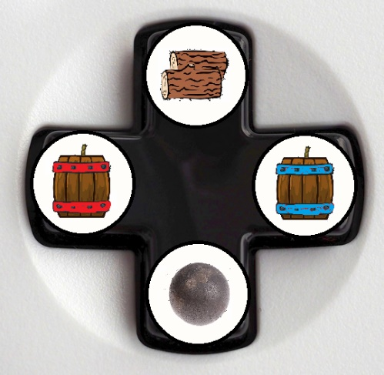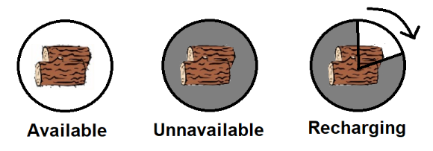

## Crow nest telegraphing

* Speaks in pictures
* Crow’s nest will appear short (unrealistic height) to remove screen obstruction. This will also give more associated screen space to display multiple UI indications at once.

# Rewards:

# Resources:

## In level resources

* No limit on number of uses
* If used by a player, the resource becomes unavailable, enters a recharge state and remains unavailable until the recharge has completed.

# characters

## Who or what are characters in the game

* Characters in the game are crew members.
* Players select their characters at the main menu screen.
* Players main colour matches their controller number (1 = red, 2 = blue, 3 = green, 4 = yellow).
* Guest players have access to the host’s unlocks.

# Assets

## 3D assets

To achieve MVP, minimal visual assets will need to be produced. Team have recognised risk associate with production of models so have identified asset packs which contain models suited to the teams needs and ability. Models contained are untextured, coloured by material and team have sufficient ability to edit existing models if required.

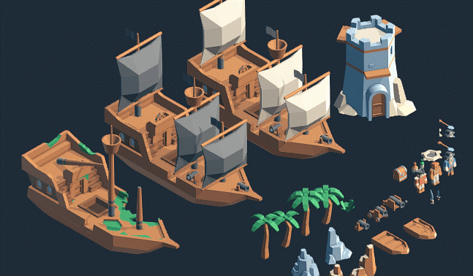

Team can produce the remaining 3D assets which are not included within the asset pack.

### Included within asset pack:

* Ship
* Cannon ball
* Ship damage variants
* Cannon variants (small to large)
* Treasure chest
* Palm tree
* Characters (will be used for players)

### 3D assets included in pack which team will need to modify:

* Cannon ball impact damage
* Cannon ball deck repair
* Permanent deck damage

### 3D assets team will produce:

* Desert island
* Cargo hatch
* Mop
* Bucket
* Gunpowder barrel
* Whale’s tail

## Animations:

* cannon throb when enemy within range
* crow’s nest speech bubble
* waving player flag

## Particle effects:

* Player ship hit with cannon ball, explosion, wood particles
* Enemy ship hit with player cannon, wood particles

## 2D / UI assets:

* Skull and crossbones flag (white bones)
* Skull and crossbones flag (red bones)
* British navy flag
* Variants of all flags damage
* Resource icons
* Images of crow’s nest callouts
* UI background panels (treasure map style)
* Completion bars to indicate time remaining for each activity

# MVP Design Overview Flowchart

Successfully complete level

Player Select / Player + Ship Customisation

New Game

Play Level

Launch Game

Main Menu

Continue to Next Level

# Initial level (tutorial) gameplay

Tutorial level will occur on a new hosts first time playing the game. ‘Tutorial’ will always remain a selectable option from the main menu to allow guest players to learn the games mechanics if playing on a veteran host account.

Tutorial level will drip-feed mechanics to the player.

“Crow’s nest” UI alerts (images within speech bubbles) will indicate how each successive action should be performed. This will guide players through each activity and hazard, showing the visual cues for each hazard and the appropriate response.

The order in which hazards/activities will be introduced to new players will be determined by playtesting later in development, though the style of approach will remain the same.

Playtesting will also reveal whether all hazards/activities will be contained within the first level, or whether some mechanics should be added in subsequent levels to ramp difficulty as the player become more experienced to maintain the pressure of the game.

Level will be loaded

Crow’s nest will display UI warning

Once the warning has been on-screen for 1 second (to give players opportunity to become familiar with the image), the game will pause

Crow’s nest UI speech bubble contents will be replaced with a ‘slide-show’ of images, descriptive of what and how the player must interact with to complete the action

When the ‘slide-show’ is complete, the game will resume

Once introduced, a mechanics ‘slide-show’ will not be shown again. The first hazard will repeat without the addition of any further mechanic 3 times, to familiarise players with the steps required

Further mechanics will be introduced with their own ‘slide-show’, the first time a hazard/activity is introduced, no other hazards/activities will be allowed to trigger, so that players can all focus on the new mechanic and see steps required

Once one instance of the new hazard/activity has been introduced, the game will continue as normal and it will be added to the list of possible hazards/activities to trigger

In addition to this way of introducing a mechanic, the loading screen can be used to display a single complete image of all stages required to complete a task.

The extra screen space and time (while loading) this can be displayed for may be more easily interpreted by players.

Once play tested approach(es) will be finalised.